|  |
| --- |
|  |
| 20 |

**السؤال الأول**

**ظللي الاختيار الصحيح لكل من الأسئلة التالية في ورقة الإجابة الخارجية المرفقة**

1. يدور محرك سيارة 180 دورة في الدقيقة فكم يدور في الثانية؟

|  |  |  |  |  |  |  |  |  |  |  |
| --- | --- | --- | --- | --- | --- | --- | --- | --- | --- | --- |
| أ | 3 دورات |  | ب | 10 دورات |  | ج | 30 دورة |  | د | 60 دورة |

1. العددان التاليان في النمط التالي 1 ،1 ،2 ،6 ،24 ... هما

|  |  |  |  |  |  |  |  |  |  |  |
| --- | --- | --- | --- | --- | --- | --- | --- | --- | --- | --- |
| أ | *120 و 720* |  | ب | 130 و 720 |  | ج | 133 و 766 |  | د | 145 و 688 |

1. قيمة العبارة 23 تساوي...

|  |  |  |  |  |  |  |  |  |  |  |
| --- | --- | --- | --- | --- | --- | --- | --- | --- | --- | --- |
| أ | 6 |  | ب | 9 |  | ج | 5 |  | د | 1 |

1. 48 بصورة ضرب العامل في نفسه تساوي...

|  |  |  |  |  |  |  |  |  |  |  |
| --- | --- | --- | --- | --- | --- | --- | --- | --- | --- | --- |
| أ | $$8×8×8×8$$ |  | ب | $$8+8+8+8$$ |  | ج | $$8×4$$ |  | د | $$8+4$$ |

1. $6+(3-12)$ تساوي...

|  |  |  |  |  |  |  |  |  |  |  |
| --- | --- | --- | --- | --- | --- | --- | --- | --- | --- | --- |
| أ | 14 |  | ب | 15 |  | ج | 3 |  | د | 7 |

1. $6+4×3$ عبارة عددية ولإيجاد قيمتها نستعمل ...

|  |  |  |  |  |  |  |  |  |  |  |
| --- | --- | --- | --- | --- | --- | --- | --- | --- | --- | --- |
| أ | *التناسب* |  | ب | المعدل |  | ج | ترتيب العمليات |  | د | القوى والأسس |

1. ضرب عدد في 5 ثم أضيف الى ناتج الضرب 4 ، فكان الناتج 24 ، فما العدد ..

|  |  |  |  |  |  |  |  |  |  |  |
| --- | --- | --- | --- | --- | --- | --- | --- | --- | --- | --- |
| أ | 4 |  | ب | 6 |  | ج | 20 |  | د | 24 |

|  |  |  |  |  |  |  |  |  |  |  |
| --- | --- | --- | --- | --- | --- | --- | --- | --- | --- | --- |
| أ | *14* |  | ب | 6 |  | ج | 10 |  | د | 4 |

1. قيمة $4-س$ إذا كانت $10=س$
2. حل المعادلة $13=7+ب$ ذهنياً تساوي ...

|  |  |  |  |  |  |  |  |  |  |  |
| --- | --- | --- | --- | --- | --- | --- | --- | --- | --- | --- |
| أ | 10 |  | ب | 20 |  | ج | 6 |  | د | 8 |

|  |  |  |  |  |  |  |  |  |  |  |
| --- | --- | --- | --- | --- | --- | --- | --- | --- | --- | --- |
| أ | *15* |  | ب | 40 |  | ج | 10 |  | د | 54 |

1. حل المعادلة $6=\frac{د}{9}$ ذهنياً تساوي...
2. $2+3=3+2$ تسمى بخاصية ...

|  |  |  |  |  |  |  |  |  |  |  |
| --- | --- | --- | --- | --- | --- | --- | --- | --- | --- | --- |
| أ | التجميع |  | ب | الإبدال |  | ج | العنصر المحايد |  | د | غير ذلك |

1. أي عبارة مما يأتي يمكن كتابتها على الصورة $(8+9)6$

|  |  |  |  |  |  |  |  |  |  |  |
| --- | --- | --- | --- | --- | --- | --- | --- | --- | --- | --- |
| أ | $$9×8+6×8$$ |  | ب | $$8×6+9×6$$ |  | ج | $$8×6×9×6$$ |  | د | $$8+6×9+6$$ |

1. تسمى مجموعة قيم المدخلات بـ ...

|  |  |  |  |  |  |  |  |  |  |  |
| --- | --- | --- | --- | --- | --- | --- | --- | --- | --- | --- |
| أ | المدى |  | ب | الدالة |  | ج | المجال |  | د | قاعدة الدالة |

1. العدد الصحيح الذي يمثل عن خسارة 5 ريالات ...

|  |  |  |  |  |  |  |  |  |  |  |
| --- | --- | --- | --- | --- | --- | --- | --- | --- | --- | --- |
| أ | *5* |  | ب | $$5-$$ |  | ج | 25 |  | د |  |



|  |  |  |  |  |  |  |  |  |  |  |
| --- | --- | --- | --- | --- | --- | --- | --- | --- | --- | --- |
| أ | $$9-$$ |  | ب | 5 |  | ج | 14 |  | د | 7 |

1. قارن بين $4-$ $6-$

|  |  |  |  |  |  |  |  |  |  |  |
| --- | --- | --- | --- | --- | --- | --- | --- | --- | --- | --- |
| أ | $$>$$ |  | ب | $$=$$ |  | ج | $$<$$ |  | د | غير ذلك |

1. تقع النقطة $(2 ، 1)$ في الربع ...

|  |  |  |  |  |  |  |  |  |  |  |
| --- | --- | --- | --- | --- | --- | --- | --- | --- | --- | --- |
| أ | الأول |  | ب | الثاني |  | ج | الثالث |  | د | الرابع |

1. $5+(3-)$ تساوي ...

|  |  |  |  |  |  |  |  |  |  |  |
| --- | --- | --- | --- | --- | --- | --- | --- | --- | --- | --- |
| أ | $$8-$$ |  | ب | $$15-$$ |  | ج | $$4$$ |  | د | $$2$$ |

1. $\left(6-\right)+8-$ تساوي ...

|  |  |  |  |  |  |  |  |  |  |  |
| --- | --- | --- | --- | --- | --- | --- | --- | --- | --- | --- |
| أ | $$14-$$ |  | ب | $$2-$$ |  | ج | 2 |  | د | $$14$$ |

1. $\left(2-\right)-1$**تساوي ...**

|  |  |  |  |  |  |  |  |  |  |  |
| --- | --- | --- | --- | --- | --- | --- | --- | --- | --- | --- |
| أ | $$1$$ |  | ب | $$3$$ |  | ج | $$1-$$ |  | د | $$3-$$ |

1. إذا كانت $5=ب$ فإن $10-ب$ تساوي..

|  |  |  |  |  |  |  |  |  |  |  |
| --- | --- | --- | --- | --- | --- | --- | --- | --- | --- | --- |
| أ | *15* |  | ب | $$10-$$ |  | ج | 50 |  | د | $$5-$$ |

1. $\left(2-\right)×9$ يساوي ...

|  |  |  |  |  |  |  |  |  |  |  |
| --- | --- | --- | --- | --- | --- | --- | --- | --- | --- | --- |
| أ | 7 |  | ب | $$18-$$ |  | ج | 18 |  | د | 3 |



|  |  |  |  |  |  |  |  |  |  |  |
| --- | --- | --- | --- | --- | --- | --- | --- | --- | --- | --- |
| أ | $$20-$$ |  | ب | $$2-$$ |  | ج | $$99$$ |  | د | $$99-$$ |

1. $\left(10-\right)÷80$ تساوي ...

|  |  |  |  |  |  |  |  |  |  |  |
| --- | --- | --- | --- | --- | --- | --- | --- | --- | --- | --- |
| أ | $$70-$$ |  | ب | $$70$$ |  | ج | $$8$$ |  | د | $$8-$$ |

1. تكتب العبارة (عدد إزداد بمقدار ثمانية ) بصورة جبرية

|  |  |  |  |  |  |  |  |  |  |  |
| --- | --- | --- | --- | --- | --- | --- | --- | --- | --- | --- |
| أ | $$س2+8$$ |  | ب | $$س8$$ |  | ج | $$8+س$$ |  | د | $$س8+2$$ |

1. تكتب العبارة ( سبعة امثال الكتب يساوي أربعة عشر ) بصورة معادلة

|  |  |  |  |  |  |  |  |  |  |  |
| --- | --- | --- | --- | --- | --- | --- | --- | --- | --- | --- |
| أ | $$14=ك7$$ |  | ب | $$7=ك14$$ |  | ج | $$14+7=ك$$ |  | د | $$7=14+ك$$ |

1. حل المعادلة $4-=2-س$

|  |  |  |  |  |  |  |  |  |  |  |
| --- | --- | --- | --- | --- | --- | --- | --- | --- | --- | --- |
| أ | *6* |  | ب | 2 |  | ج | $$4-$$ |  | د | $$2-$$ |

1. حل المعادلة $6=س2$

|  |  |  |  |  |  |  |  |  |  |  |
| --- | --- | --- | --- | --- | --- | --- | --- | --- | --- | --- |
| أ | *2* |  | ب | 3 |  | ج | $$3-$$ |  | د | $$2-$$ |

1. المسافة حول شكل هندسي تسمى ..

|  |  |  |  |  |  |  |  |  |  |  |
| --- | --- | --- | --- | --- | --- | --- | --- | --- | --- | --- |
| أ | مساحة |  | ب | محيط |  | ج | العرض |  | د | الطول |

1. مساحة المستطيل المقابل .....سم2

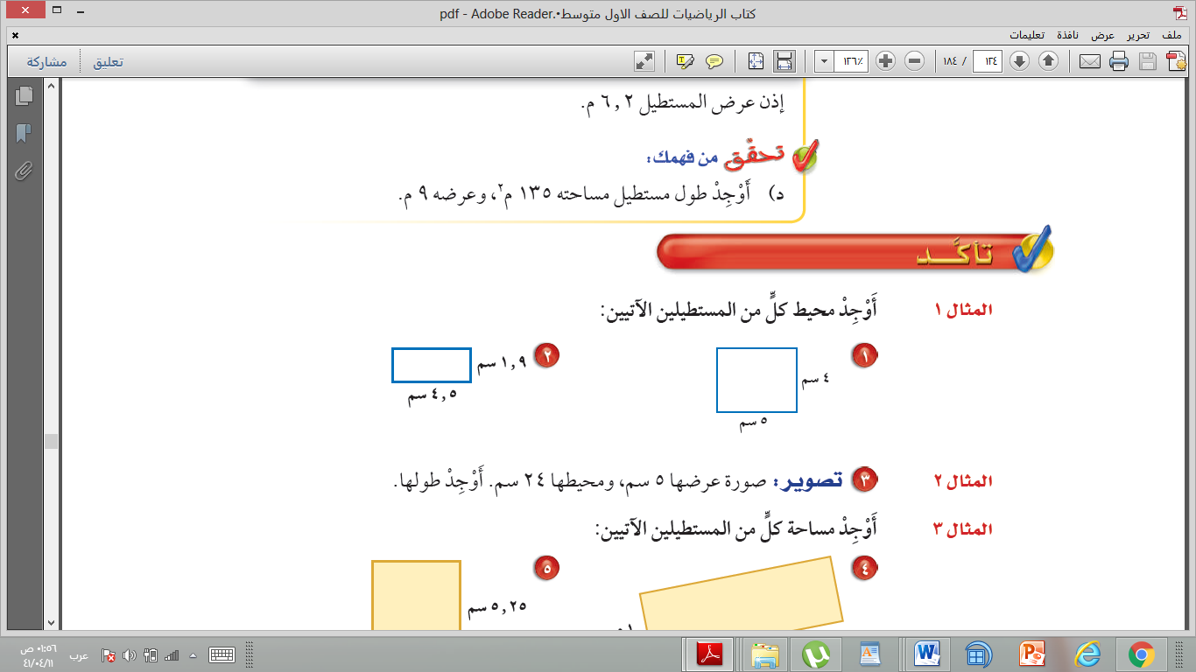

|  |  |  |  |  |  |  |  |  |  |  |
| --- | --- | --- | --- | --- | --- | --- | --- | --- | --- | --- |
| أ | *20* |  | ب | 33 |  | ج | 18 |  | د | 14 |

1. تكتب النسبة 4 أمتار إلى 12 أمتار على شكل كسر في ابسط صورة ...

|  |  |  |  |  |  |  |  |  |  |  |
| --- | --- | --- | --- | --- | --- | --- | --- | --- | --- | --- |
| أ | $$\frac{4}{3}$$ |  | ب | $$\frac{1}{2}$$ |  | ج | $$\frac{3}{4}$$ |  | د | $$\frac{1}{3}$$ |

1. معدل الوحدة لـ 300 ريال لكل 6 ساعات هو ...

|  |  |  |  |  |  |  |  |  |  |  |
| --- | --- | --- | --- | --- | --- | --- | --- | --- | --- | --- |
| أ | *300* |  | ب | $$60$$ |  | ج | 50 |  | د | 5 |

1. اكملي ما يأتي: 36 ياردة $=$.....قدم

|  |  |  |  |  |  |  |  |  |  |  |
| --- | --- | --- | --- | --- | --- | --- | --- | --- | --- | --- |
| أ | 12 قدم |  | ب | 36 قدم |  | ج | 108 قدماً |  | د | 100 قدماً |

1. أكملي مايأتي:12000رطل $=$..... طن

|  |  |  |  |  |  |  |  |  |  |  |
| --- | --- | --- | --- | --- | --- | --- | --- | --- | --- | --- |
| أ | *2400* |  | ب | 12000 |  | ج | 24 |  | د | 6 |

1. الوحدة الأساسية للسعة هي ...

|  |  |  |  |  |  |  |  |  |  |  |
| --- | --- | --- | --- | --- | --- | --- | --- | --- | --- | --- |
| أ | اللتر |  | ب | المتر |  | ج | الكيلوجرام |  | د | جرام |

1. أكملي مايأتي: $25,4$ جم $=$.....كجم

|  |  |  |  |  |  |  |  |  |  |  |
| --- | --- | --- | --- | --- | --- | --- | --- | --- | --- | --- |
| أ | $$2,054$$ |  | ب | $$2540$$ |  | ج | $$2,54$$ |  | د | $$0,0254$$ |

1. أكملي مايأتي: $3,7$ م $=$..... سم

|  |  |  |  |  |  |  |  |  |  |  |
| --- | --- | --- | --- | --- | --- | --- | --- | --- | --- | --- |
| أ | *37* |  | ب | 370 |  | ج | $$0,37$$ |  | د | $$0,037$$ |

1. حل التناسب التالي : $\frac{س}{8}=\frac{2}{4}$ هو ...

|  |  |  |  |  |  |  |  |  |  |  |
| --- | --- | --- | --- | --- | --- | --- | --- | --- | --- | --- |
| أ | $$6=س$$ |  | ب | $$4=س$$ |  | ج | $$7=س$$ |  | د | $$2=س$$ |

1. ماعامل المقياس في نموذج مركب شراعي إذا كان المقياس 1سم $=$ 2متر

|  |  |  |  |  |  |  |  |  |  |  |
| --- | --- | --- | --- | --- | --- | --- | --- | --- | --- | --- |
| أ | $$\frac{1}{200}$$ |  | ب | $$\frac{1}{20}$$ |  | ج | $$\frac{1}{0,002}$$ |  | د | $$\frac{1}{2}$$ |

1. يكتب الكسر الإعتيادي $\frac{3}{5}$ في صورة نسبة مئوية ...

|  |  |  |  |  |  |  |  |  |  |  |
| --- | --- | --- | --- | --- | --- | --- | --- | --- | --- | --- |
| أ | 20% |  | ب | 40% |  | ج | 60% |  | د | 80% |

|  |
| --- |
|  |
| 4 |

**السؤال الثاني**

**ضعي علامة 🗸**أمام العبارة الصحيحة وعلامة **🗴** أمام العبارة الخاطئة

**بتظليل رقم 1 أو 2 في ورقة الإجابة الخارجية المرفقة**

|  |  |  |  |
| --- | --- | --- | --- |
|  | العـــــــــــــــــــــــــــــــــبـــــــــــارة | **🗸** | **🗴** |
| 41 | العامل المتكرر في عملية الضرب يسمى الأساس |  |  |
| 42 | ناتج $3=4÷12-$ |  |  |
| 43 | إذا اضفت العدد نفسة الى طرفي المعادلة فإن طرفيها يبقيان متساويين |  |  |
| 44 | المعادلات ذات الخطوتين يستعمل لحلها عمليتان مختلفتان |  |  |
| 45 | تسمى النقطة التي يتقاطع فيها خطا الأعداد ارباعاً |  |  |
| 46 | حل المعادلة $14=س7$ هو $2-$ |  |  |
| 47 | تكتب النسبة المئوية لـ 20 % على صورة كسر اعتيادي في ابسط صورة $\frac{1}{20}$ |  |  |
| 48 | مجموع أي عدد ونظيره الجمعي يساوي صفر |  |  |

**السؤال الثالث :**

|  |
| --- |
|  |
| 3 |

1. اكتبي الزوج المرتب الذي يقابل النقطه هـ

هـ(.....،.....) تقع في الربع ...........

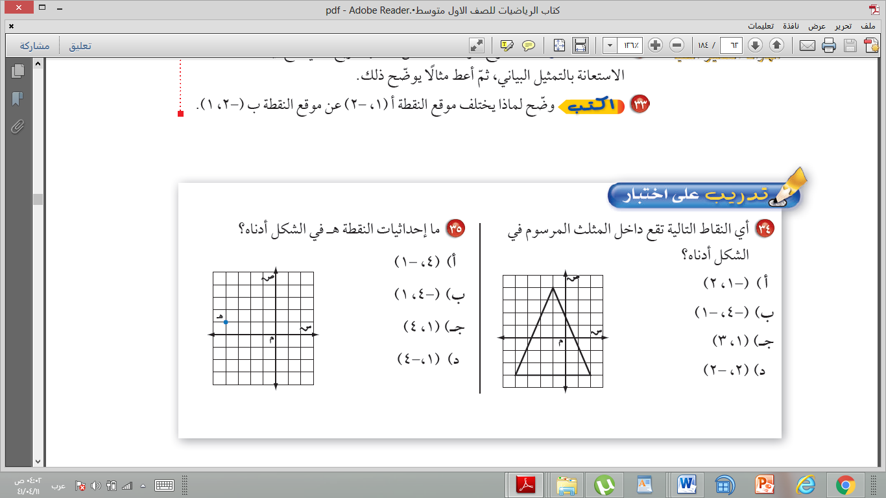

1. حلي المعادلة التالية وتحققي من صحة الحل :

$$7=1+س3$$

|  |  |
| --- | --- |
| الحل |  |

1. أوجدي محيط المستطيل الذي طوله 4 سم وعرضة 3 سم ؟ مع ذكر القانون

**.............................................................................................**

**.............................................................................................**

**.............................................................................................**

**.............................................................................................**

|  |
| --- |
|  |
| 3 |

**السؤال الرابع:**

1. مثلي المعادلة $1+س=ص$ بيانياً

|  |  |  |  |  |  |  |  |  |  |  |  |  |  |
| --- | --- | --- | --- | --- | --- | --- | --- | --- | --- | --- | --- | --- | --- |
| |  |  |  |  | | --- | --- | --- | --- | | **س** | $$1+س$$ | **ص** |  | | **1** |  |  |  | | **2** |  |  |  | |  |

1. اكملي الجدول وحددي المجال والمدى

|  |  |  |
| --- | --- | --- |
| س | 5س | ص |
| 1 |  |  |
| 2 |  |  |
| 3 |  |  |
| 4 |  |  |

المجال $=$} {

المدى $=$} {

1. استخدمي خاصية التوزيع لحل :

$$\left(2+3\right)5$$

**انتهت الأسئلة ،،،تمنياتي بالتوفيق**

**معلمة المادة/مشاعل الحربي**