**السؤال الأول : أُكْـتُـبْ اسْـمَ الصُّـورَةِ :**

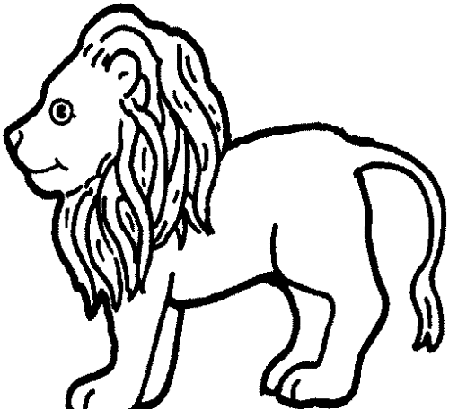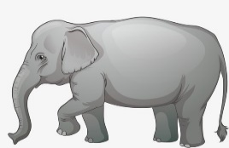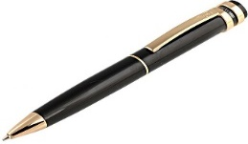

...............أسد............

..........قلم......................

........فيل...................

**السؤال الثاني : أحلل إلى مقاطع وحروف صوتية :**

|  |  |  |  |
| --- | --- | --- | --- |
| **صَـبَـرَ** | ......ص.......... | ....ب........... | ..ر......... |
| **دَارُ** | .....دا........ | ...ر............ |  |
| **دِينُ** | ...دي......... | ....ن........... |  |

**السؤال الثالث :** **أُكْمِل ُبِحَرْفِ الْـمَد**

**( حُــ.....ت )**

|  |  |  |
| --- | --- | --- |
| **ا** | **و** | **ي** |

**صَـ.... مَ**

|  |  |  |
| --- | --- | --- |
| **و** | **ا** | **ي** |

**فِـ.... لُ**

|  |  |  |
| --- | --- | --- |
| **و** | **ا** | **ي** |

**نُـ.... رُ**

|  |  |  |
| --- | --- | --- |
| **و** | **ا** | **ي** |